**Power Supply Component Pinout and Polarities**

(jas, Power Supply Component Pinout and Polarities.docx, 12/01/2023)

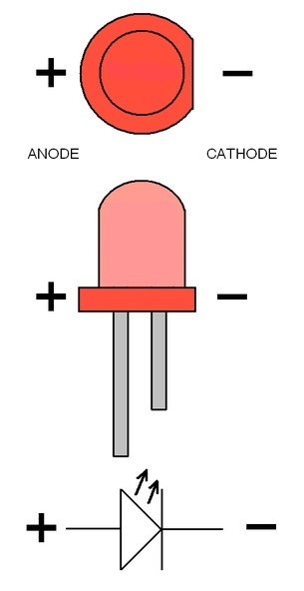**Figure 1** illustrates a top and side view of a packaged through-hole LED, along with the schematic symbol. Some through-hole LEDs do not have the flat surface associated with the cathode, i.e., negative terminal. The negative lead of an LED is the shorter lead.

**Figure 1**. Light Emitting Diode and Polarity (LED).

Aluminum electrolytic capacitors are polarized capacitors with the negative terminal indicated by the curved plate as illustrated in **Figure 2**.

**Figure 2**. Schematic Symbol for Polarized Capacitor.

For through-hole aluminum electrolytic capacitors the gray polarity band illustrated in **Figure 3**, indicates the negative lead. Like LEDs the negative lead of an aluminum electrolytic capacitor is also the shorter lead.

**Figure 3**. Through-Hole Aluminum Electrolytic capacitors.

The schematic symbol illustrated in **Figure 4** is for a npn bipolar transistor, with the three terminals referred to as Emitter (E), Base (B) and Collector (C), with the arrowhead denoting the emitter terminal.

**Figure 4**. Schematic Symbol for a npn Bipolar Junction Transistor.

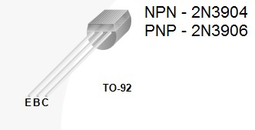The actual TO-92 package, and associated leads of a bipolar junction transistor is illustrated in **Figure 5**.

**Figure 5**. TO-92 Bipolar Junction Transistor Package.

The 100 V n-channel MOSFET transistor package and pinout is illustrated in **Figure 6**.

**Figure 6**. 100 V n-channel MOSFET Transistor Package and Pinout.

The LM358 dual op-amp 8-pin DIP package and pinout is illustrated in **Figure 7**.

**Figure 7**. LM358 Dual Op-Amp 8-pin DIP Package and Pinout.

The LM385-2.5 V voltage regulator diode package and pinout is illustrated in **Figure 8**.

**Figure 8**. LM385-2.5 V Voltage Regulator Diode Package and Pinout.